**Level Design Document for:**

*Awesome Title*

All work Copyright ©2021

Written by Team AIE Production

Table of Contents

1.0 Revision History 4

2.0 level Design Overview 4

2.1 Level Design concept 4

2.2 Gameplay Mechanics 4

2.3 Camera 4

3.0 Theme and Characters 4

3.1 Characters 4

3.2 Theme 4

4.0 Level Information 5

4.1 Level Location 5

4.2 Level Setting 5

4.3 Level Layout/Architecture 5

5.0 Level Design 5

5.1 Main Objectives 5

5.2 Optional Objectives 5

5.3 WOW Moments 5

5.4 Level Progression 5

5.5 Player Experience 5

6.0 Art Style and Aesthetics 6

6.1 References 6

6.2 Lighting 6

6.3 SFX/Music 6

6.4 Particle FX 7

7.0 Level Asset List 7

8.0 Delivery Milestones 7

# 1.0 Revision History

<As you revise the document, list what was changed and when it was changed>

|  |  |
| --- | --- |
| Version | Description |
| 1.0 | Initial document |

# 2.0 level Design Overview

## 2.1 Level Design concept

Large clearing, blocked off by large trees and nature.

## 2.2 Gameplay Mechanics

<Player and gameplay mechanics used in the level design including how your environment will support them>

* Movement (backwards, forwards, right and left) (jumping)
* Collection of orbs
* Platforms
* puzzles

## 2.3 Camera

1st person camera.

# 3.0 Theme and Characters

## 3.1 Characters

Main character: a deer or ghost who is alone and must earn orbs to gain freedom to leave the forests grasp.

## 3.2 Theme

Fantasy

# 4.0 Level Information

## 4.1 Level Location

Mysterious and fantastical forest

## 4.2 Level Setting

## 4.3 Level Layout/Architecture

Ancient civilization, god aesthetic combined with overgrown nature.

# 5.0 Level Design

## 5.1 Main Objectives

<This is a body of text and should be elaborated, how do you progress? Open world? Interior? Sequential? Pick-a-path? Procedural?> An open range map is left for the player to roam and solve. To complete the tutorial all orbs must be found and returned to the main landmark (a statue).

## 5.2 Optional Objectives

## 5.3 WOW Moments

<Side missions, free roam, secrets>

## 5.4 Level Progression

*<Difficulty cure, Progression Diagram or Beat Sheet>*

## 5.5 Player Experience

*<What is motivating the player? Emergent gameplay opportunities>*

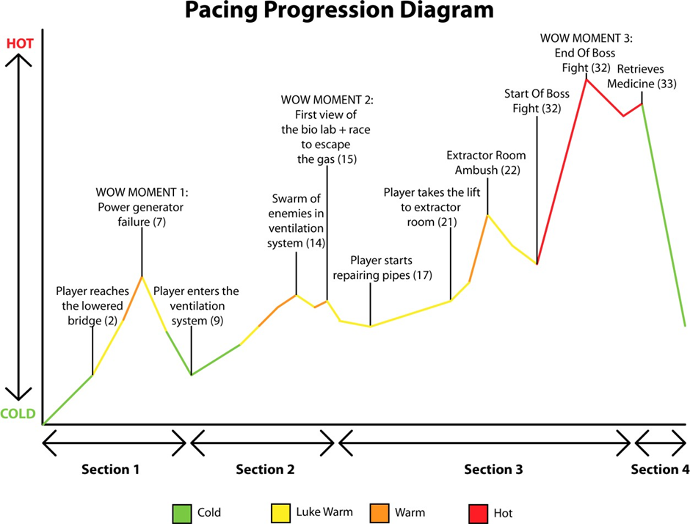

# 6.0 Art Style and Aesthetics

Refer to the Mood Boards and 2D level Design maps

## 6.1 References

<Provide images here or links to mood boards and reference images>

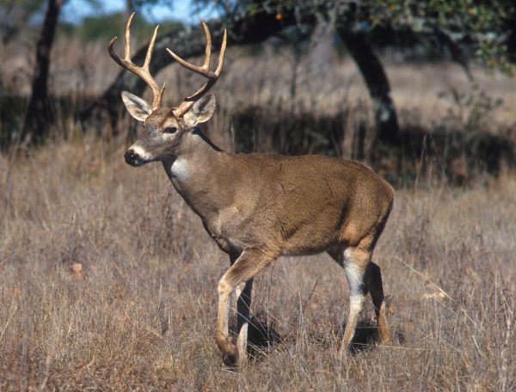 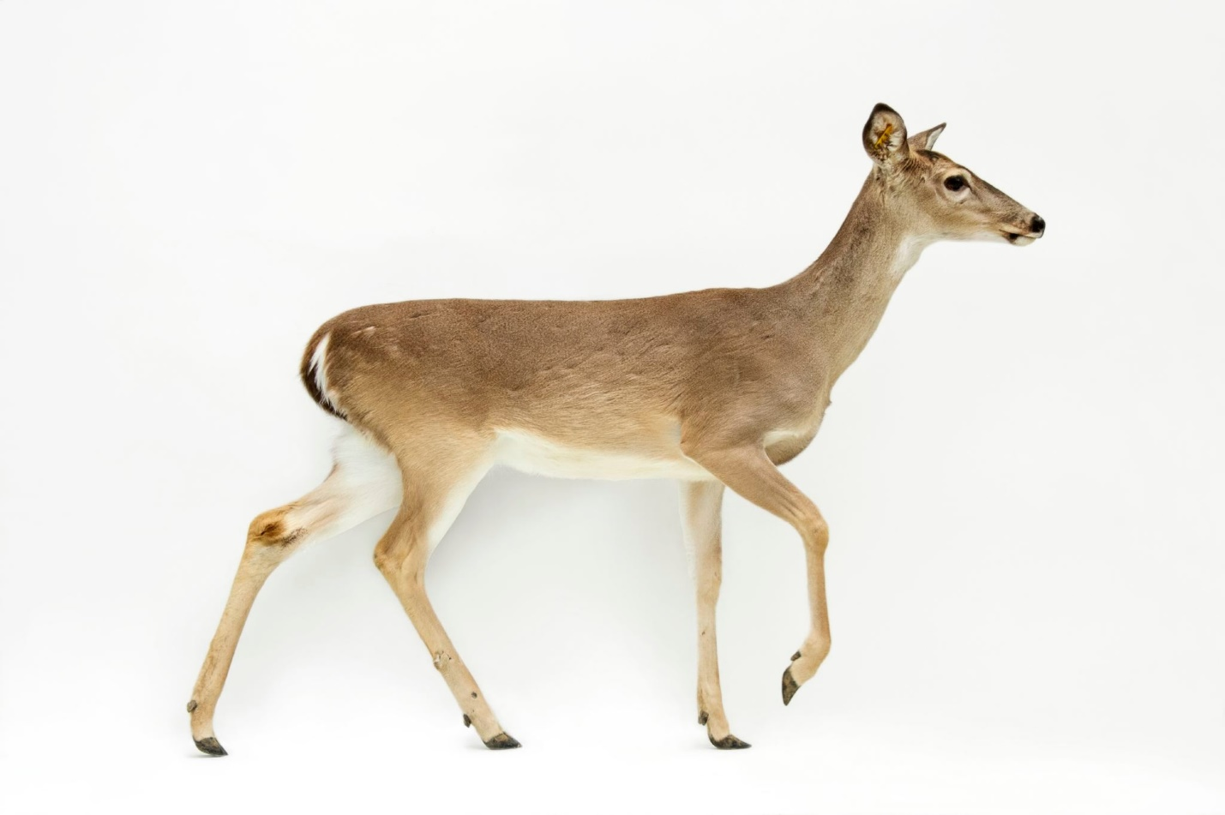 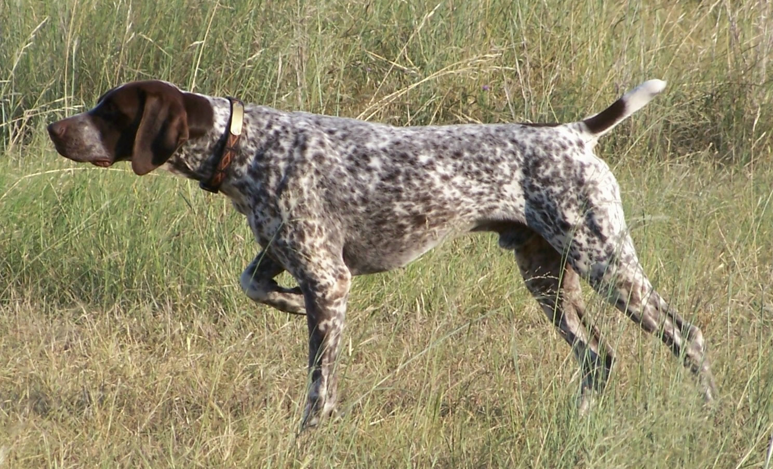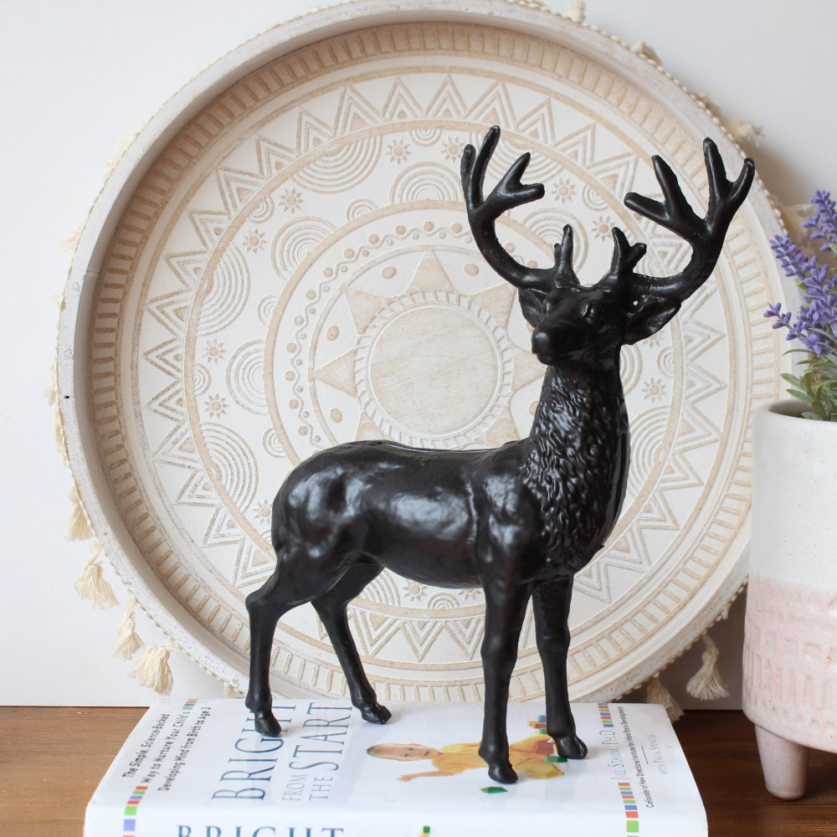

## 6.2 Lighting

<Color ,mood, Signposting, Narrative >

* Purples and red colors, dulled and moody

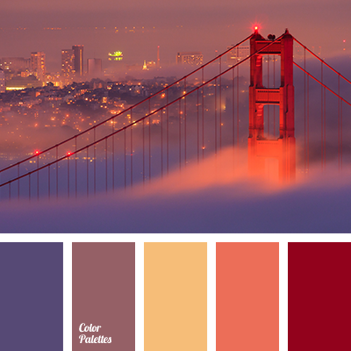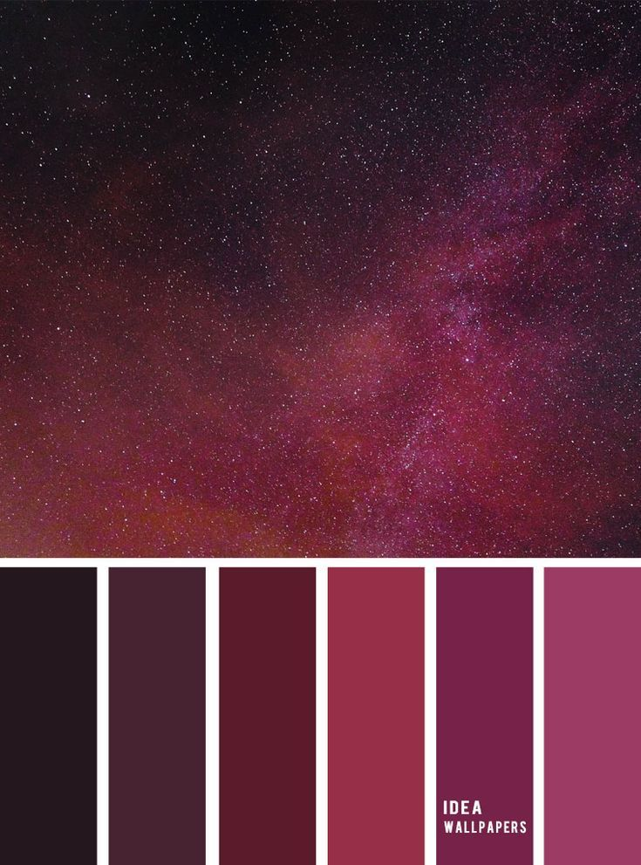

## 6.3 SFX/Music

List music clips and where they’re used.

List all sound effects and where they’re used

## 6.4 Particle FX

List particle effects and why they are used

* Mist/fog: mysterious

# 7.0 Level Asset List

<Static and dynamic objects relative to the environment>

|  |  |
| --- | --- |
| Item | Description |
| Statue (check to see if you have found all orbs, it shows the exit) | Godly male (antlers) deer being with plant life growing upon them. |
| orb | Collectable glowing orbs. AKA spirit shrooms. |
| Character |  |
| Wall of forest | An impassable wall that has indents to make it look as if it is impassable with crowded trees. |
| waterfall | The waterfall falls down into a part of the land that has been built up to make the illusion of it being a pool of water. |
| Shrubs and grass |  |
| Mossy stones |  |
| pathway |  |
| logs |  |
| trees |  |
| platforms |  |

# 8.0 Iteration and

<Provide milestone dates for Prototype, Testing Phases and Final Build>

**Prototype:** When will your first playable prototype of your level be ready? This will be a prototype/grey-box that will show off how your level works.

**Testing and Iteration:** You will need to test your level, get feedback, and make changes to your level and design based on your testing results. Allocate time for this to be done and complete.

**Final Build:** The final polished and complete build of your game.